LEARN TO MAKE AN ARTRAGEOUS robot marker/crayon holder!

By: Karen Bagayawa

Using your imagination you can make an artrageous ROBOT. You can attach a tall cup to your robot to hold markers, pencils and crayons. He can sit on your desk or the kitchen table. Think about your robot and try to answer these questions: Is your robot wearing any clothing? What does his eyes look like? What does he say?

SUPPLIES NEEDED:

Various Sizes of Boxes, Cereal Box, Shoe Box
Cardboard Paper Towel Rolls, Toilet Paper Rolls
Aluminum Foil
Tall cup to hold markers, pencils, crayons
Coloured construction paper or patterned paper
Egg Carton
Scissors
Glue
***Glue Gun: For parents only, you can use the hot glue gun to fasten the boxes together
Collage Materials: feathers, buttons, pasta, (anything! be creative)
Googly Eyes
Pipe Cleaners
Tape

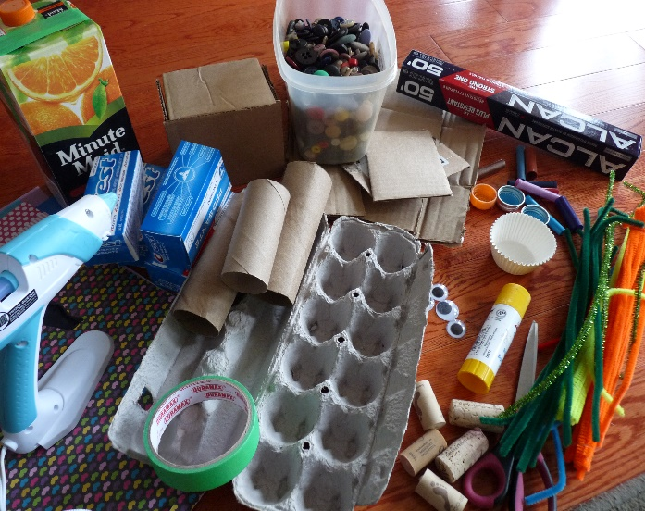

STEP #1:

Think about how you would like to assemble the HEAD, BODY, ARMS and LEGS of your robot without gluing everything together just yet. Wrap all the pieces you are going to use for your robot in aluminum foil. With my pieces of card board I created a box for the head since I did not have a small box on hand.

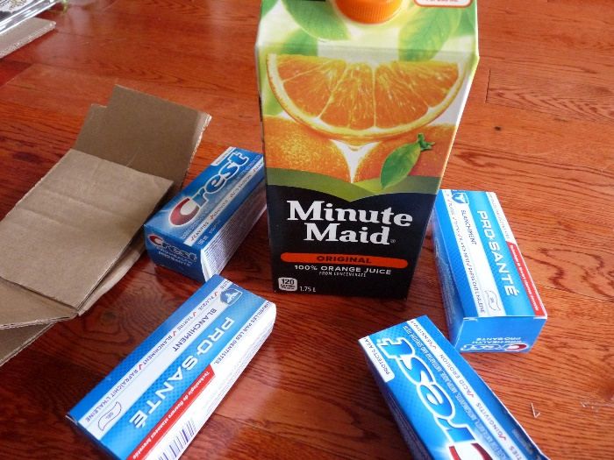

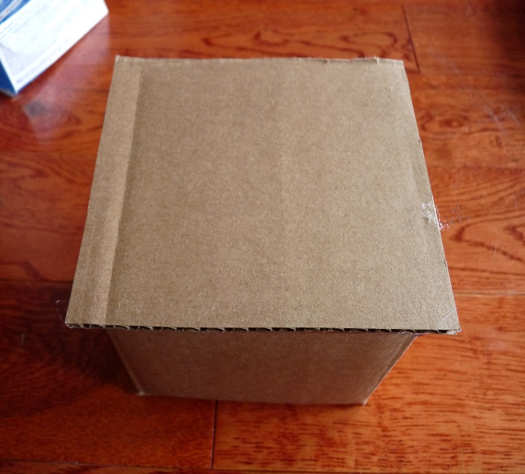

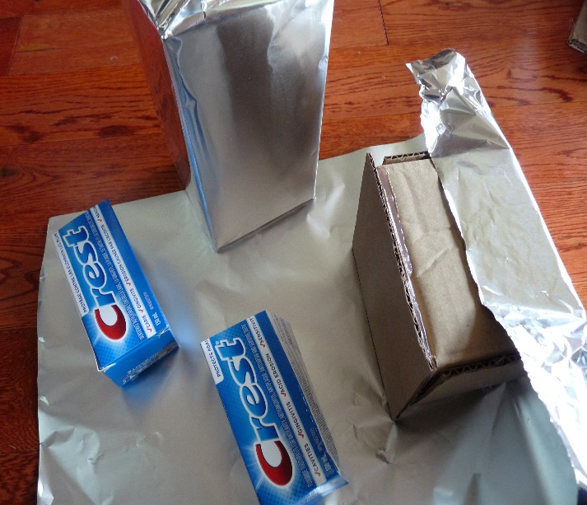

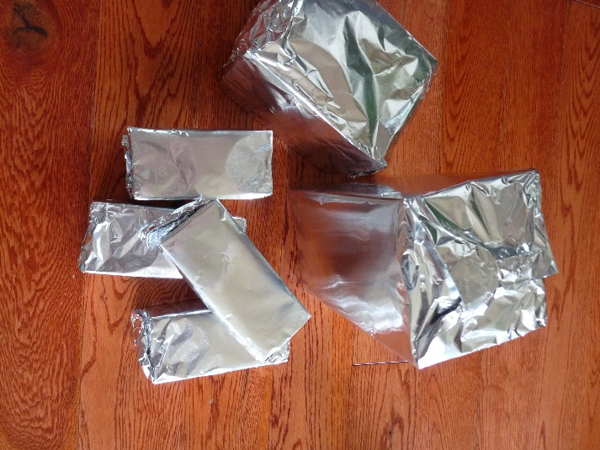

STEP #2:

Now you can work on the EYES, NOSE and MOUTH. Using scissors, cut out pieces of an egg carton. You can have two eyes or twenty eyes! I made the eyes by gluing the googly eyes on the caps then gluing onto the pieces of egg carton. I used an orange bottle cap for the nose and an old marker cap for the mouth!

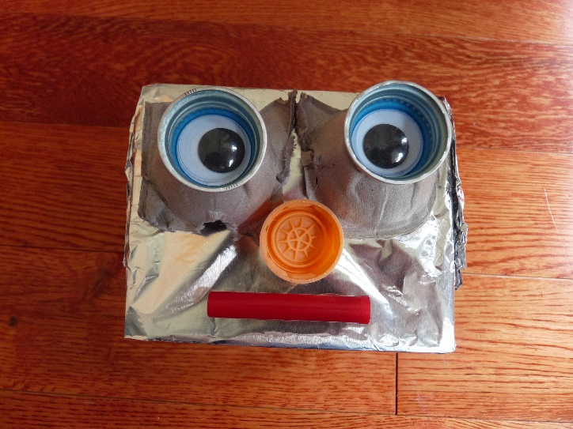

STEP #3:

***For parents using the hot glue gun***. Glue the HEAD to the body. Then the ARMS and LEGS.

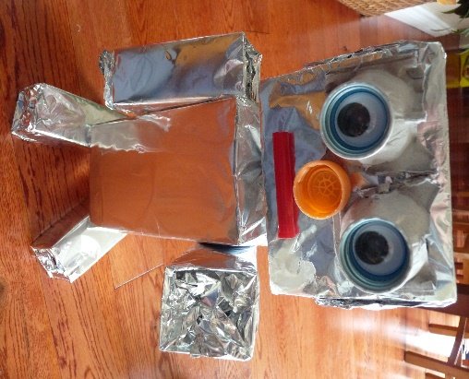

STEP #4:

Lastly, wrap the cup in foil paper and glue the cup to the robot to hold markers/crayons. When gluing the cup ensure the bottom of the cup can sit on a table.

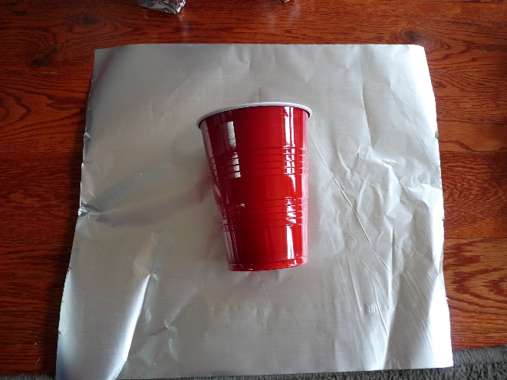

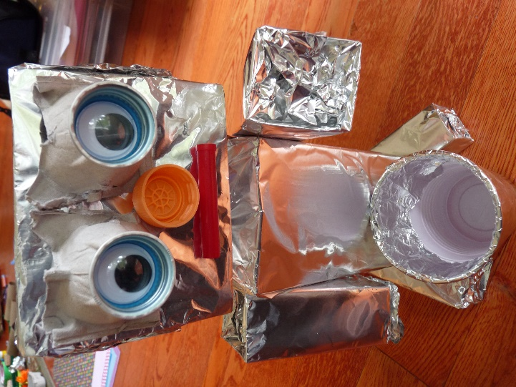

STEP #5:

Using coloured construction paper or patterned paper and your collage materials, you can decorate your robot. Is he/she wearing a shirt with some coloured buttons? Is he/she wearing a hat? Here I wrapped pipe cleaners on my finger like a spring and pop! I glued them to my robot’s face.

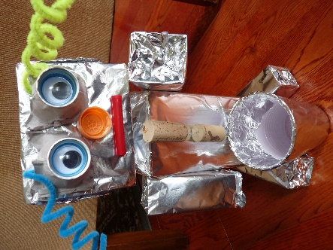

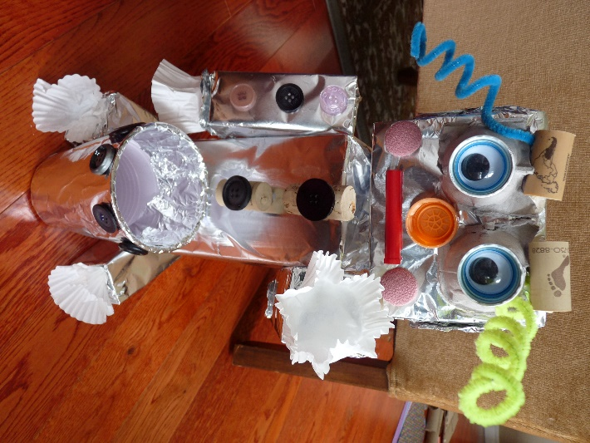

STEP #6:

Using your scissors you can cut out strips of paper for hair. I folded the paper in and out and glued the hair to my robot’s head. You may need a parent to help you with this step.

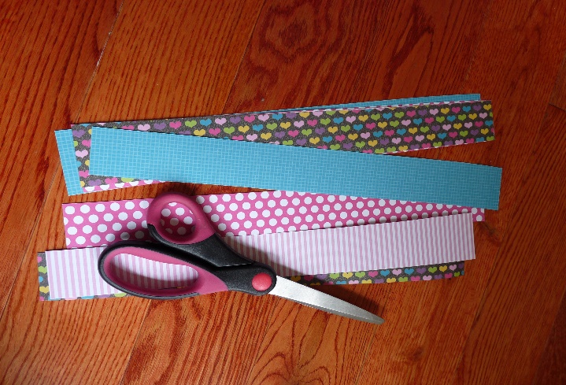

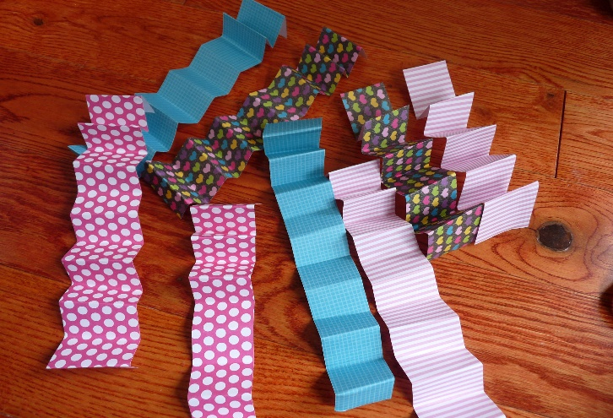

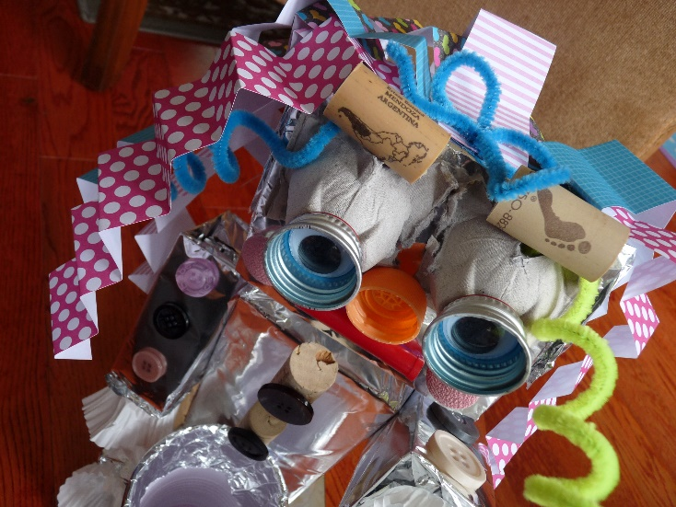

STEP #7:

Place markers, pencils and crayons in the cup and you are finished! Fantastic!! Make sure you give your robot a name and place him/her in a special spot!

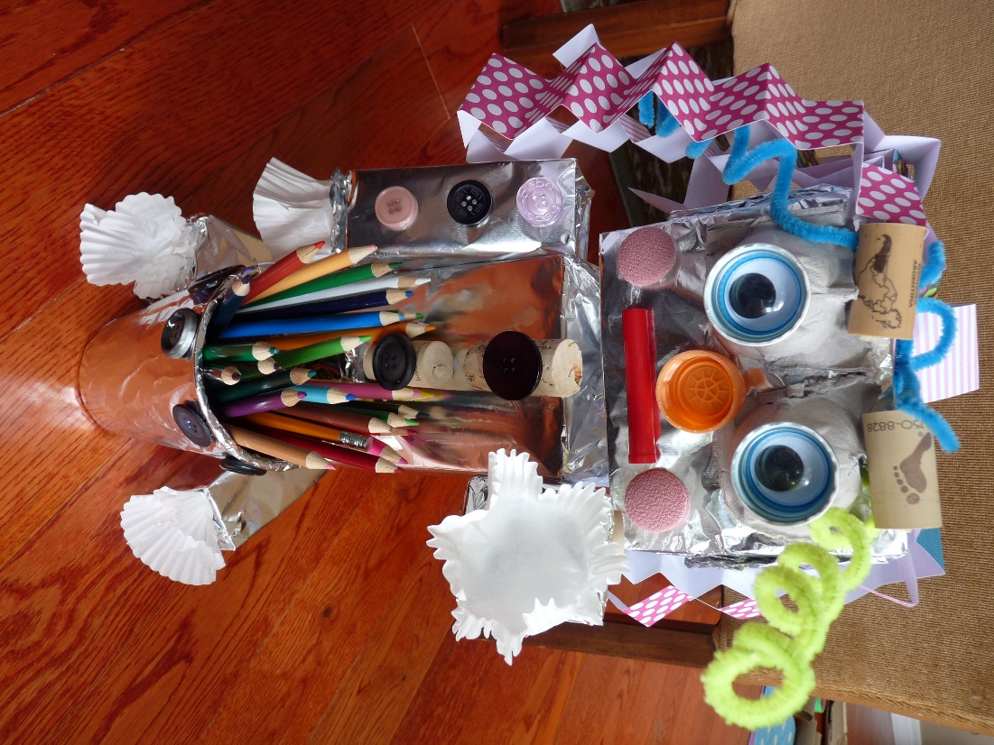

SALLY, the Artrageous Robot!

